11/18/2023

Before I get farther along – is this acceptable for allowing user to pick events and divisions to display, and navigate around? I haven’t incorporated NCWSA or Overall yet.

Questions in red in the text. Thanks.

I haven’t applied this to the Scores by Skier pages pending your approval of this idea.

1. On the Tournament Details Page. Event Selector drop list populates with only the events offered in the selected tournament.

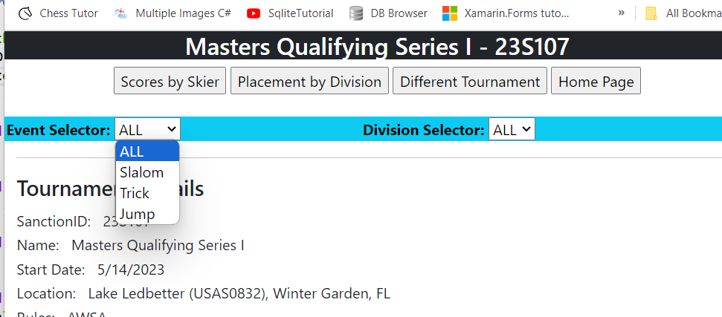

1. The Division Selector is populated with divisions with at least one entry in the selected event. When the event changes the list of divisions changes accordingly.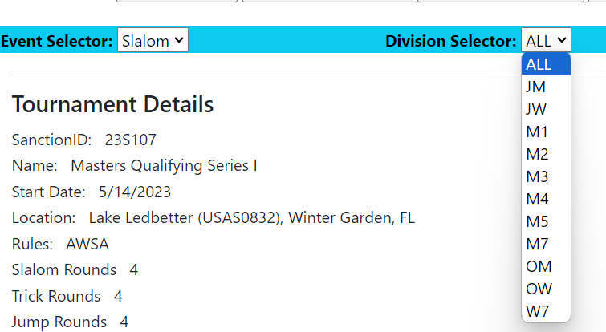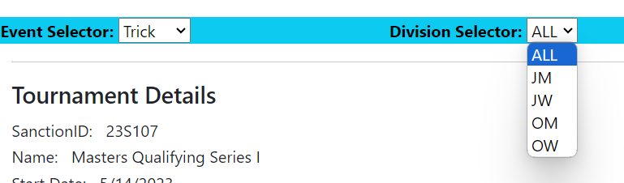
2. When Placement by Division is clicked the values in the droplists are transferred to the new page and selectedValue of the droplists are set to match. I haven’t made the display match the settings pending your approval of this approach. The Event Selector and Division Selector can be changed on this page followed by clicking the Update Display button to refresh everything from the server using the current settings of Event and Division.

Note that the data breaks by division as you asked.

I haven’t created a link on the skier’s name that would display the recap data for that skier. Not sure if that belongs here or when the Scores by Skier pages are used. To get from here to there now, the user would click on This Tournament then click Scores by Skier, and pick the skier from the list,

If I add the link from each skier name here to display their recap in a new window or tab do we still need the scores by skier pages at all? The only new information on that page would be the events and classes the skier entered and the SEE REGISTRAR warning if something is missing.

Do you think filtering by round is needed here?

Should I add Overall as a selection under Events (only if 3 events are offered), and display overall scores as an event here. That would avoid the pop up window/tab for overall.

